Procedural Markup

📌 Definition:
# Source: AI Source: Provided by: [Data Path: Persons Table -> ID Column: 1, Name_En Column: Motasem Essam] -> From: [ChatGPT] on [12/9/2025]
Procedural markup is a type of markup that uses step-by-step instructions (commands) to tell the system how to process or format content.

🧠 Simple idea:
# Source: AI Source: Provided by: [Data Path: Persons Table -> ID Column: 1, Name_En Column: Motasem Essam] -> From: [ChatGPT] on [12/9/2025]
Procedural = “How to do it” 🛠️

🔍 Key characteristics:
# Source: AI Source: Provided by: [Data Path: Persons Table -> ID Column: 1, Name_En Column: Motasem Essam] -> From: [ChatGPT] on [12/9/2025]
- 📋 Contains explicit instructions
- ⚙️ Tells the system what actions to perform
- 🔄 Processing is done step-by-step
- ❌ Less focus on meaning or structure
- ⚠️ Often used in older systems or specific tools

📌 Examples:
# Source: AI Source: Provided by: [Data Path: Persons Table -> ID Column: 1, Name_En Column: Motasem Essam] -> From: [ChatGPT] on [12/9/2025]
🖨️ LaTeX (command-based formatting)
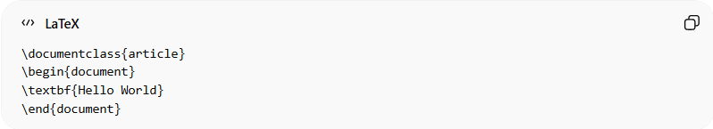
\documentclass{article}
\begin{document}
\textbf{Hello World}
\end{document}
👉 Commands tell the system exactly how to format the document.

🧾 Early formatting commands (conceptual)
# Source: AI Source: Provided by: [Data Path: Persons Table -> ID Column: 1, Name_En Column: Motasem Essam] -> From: [ChatGPT] on [12/9/2025]
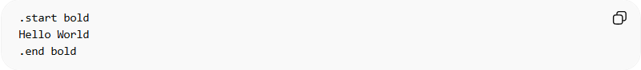
.start bold
Hello World
.end bold
👉 Step-by-step instructions control formatting.

⚙️ Real-world note:
# Source: AI Source: Provided by: [Data Path: Persons Table -> ID Column: 1, Name_En Column: Motasem Essam] -> From: [ChatGPT] on [12/9/2025]
Procedural markup is mostly used in specialized systems, not modern web development.

🆚 Procedural vs Semantic vs Presentational
# Source: AI Source: Provided by: [Data Path: Persons Table -> ID Column: 1, Name_En Column: Motasem Essam] -> From: [ChatGPT] on [12/9/2025]
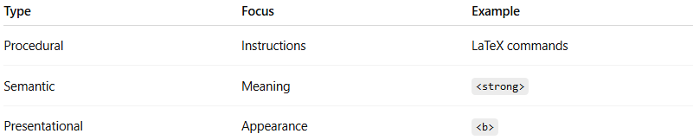
Type | Focus | Example
Procedural | Instructions | LaTeX commands
Semantic | Meaning | <strong>
Presentational | Appearance | <b>

🎯 Summary:
# Source: AI Source: Provided by: [Data Path: Persons Table -> ID Column: 1, Name_En Column: Motasem Essam] -> From: [ChatGPT] on [12/9/2025]
Procedural markup provides explicit instructions on how content should be processed, making it more like a set of commands than a description.

